Attachment II
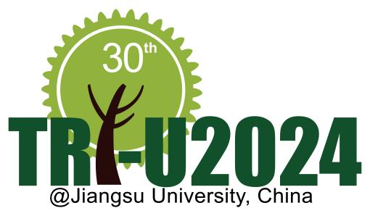
Application Form
The 30th Tri-U International Joint Seminar & Symposium 2024
Jiangsu University, China

Name | ^{(Given)} ^{(Family)}
Gender | Female Male
Academic Affiliation
Position/ Grade
Address
Address | Phone:
Address | E-mail:
Paper title*
Themes* | (Please circle one or more themes for your paper)  Population Food Energy Environment  AI and the sustainable development of human society
Smoking | I smoke. I do not smoke.
Dietary restrictions | Vegetarian Muslim Other(my allergy ⇒ )

*Only those who will present a paper should fill in these blanks.
Note: Please send this form by PDF and WORD files to tri-u2024@ujs.edu.cn
Deadline: July 15, 2024

